Dis-Indo-Sunda Is-female ancestress

27 cm / 10.5 inche

ca. mid 20th century

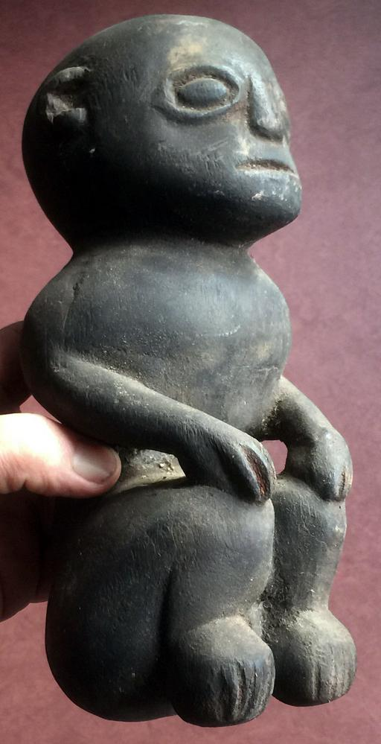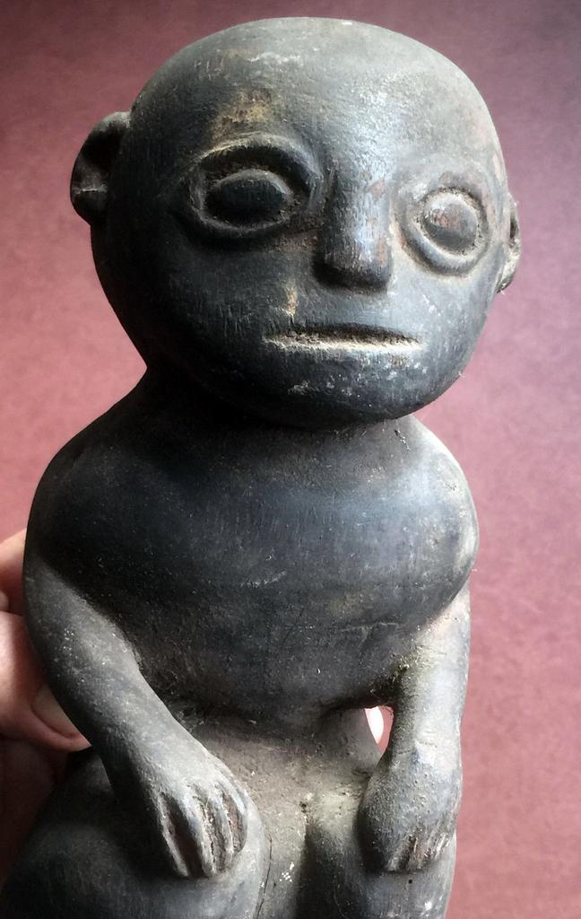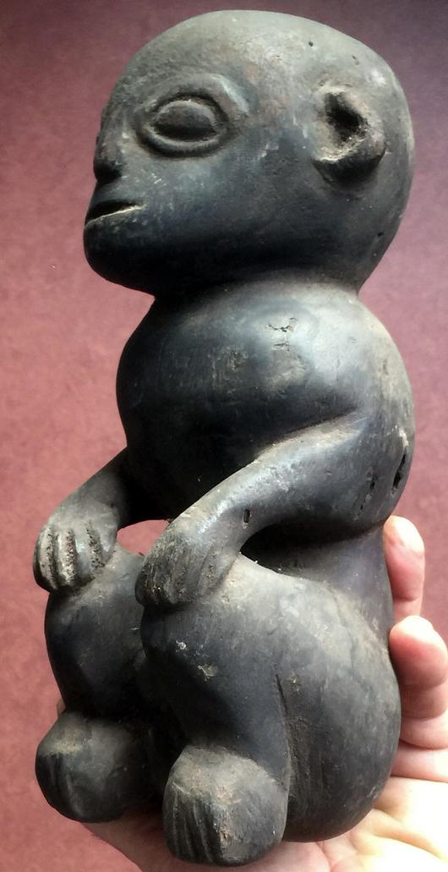

# Order details

## Sales order

Sold by [new-guinea-art](http://myworld.ebay.com/new-guinea-art) ( [9825](http://feedback.ebay.com/ws/eBayISAPI.dll?ViewFeedback&userid=new-guinea-art) )

Estimated delivery Monday, Dec 19, 2016 - Thursday, Dec 29, 2016

#### [A Fabulous female ancestor idol figure wood from Sunda Islands Indonesia](http://www.ebay.com/itm/351925286660)

|  |  |
| --- | --- |
| Item price | $31.00 |
| Quantity | 1 |
| Item number | 351925286660 |
| Shipping service | Economy Shipping |

## Shipping address

Ralph J Coffman Jr

149 Atlantic Ave

Swampscott MA 01907-2427

United States

## Order total

|  |  |
| --- | --- |
| Subtotal | $31.00 |
| Shipping | $30.00 |

**Total**

$61.00